**MINI PROJECT**

# ON

**EAT AND GREET**



## DEPARTMENT OF INFORMATION TECHNOLOGY VASANTDADA PATIL PRATISHATHAN’S COLLEGE OF ENGINEERING AND

**VISUAL ARTS MUMBAI UNIVERSITY 2022-23**

**Mini Project Report(20)**

**ON**

**EAT AND GREET (20)**

Submitted in partial fulfilment of the requirements of the requirements for the degree of Bachelor of Engineering in

Information Technology Semester-VI (14)

By

|  |  |  |
| --- | --- | --- |
| .No | Name(14) | ID No.(14) |
| 1 | Kshitij Ghuge | VU4F2021003 |
| 2 | Jagannath Mestry | VU4F2021009 |
| 3 | Pranit Temkar | VU4F2021031 |
| 4 | Abhishek Palav | VU4F2021034 |

Under the Guidance

of

## Prof. Medha Kulkarni



Department of Information Technology

Vasantdada Patil Pratishthan's College of Engineering & Visual Arts

UNIVERSITY OF MUMBAI

(AY 2021-22)

**CERTIFICATE**

This is to certify that the project entitled “Eat and Greet” is bonafide work of

Kshitij Ghughe(VU4F2021003), Jagannath Mestry(VU4F2021009), Pranit Temkar(VU4F2021031), Abhishek Palav(VU4F2021034),submitted to University

of Mumbai in partial fulfilment of requirement for the award of degree of

“Bachelor of Engineering in Information Technology-Semester-V”

Prof. Medha Kulkarni

Guide

Dr.Pradip Mane Dr. Alam N.Shaikh

Head of Department(IT) Principal & Campus Director

# Project Report Approval for T.E.

This project report entitled **“Eat and Greet”** by Kshitij Ghuge, Jagannath Mestry, Pranit Temkar, Abhishek Palav is approved for the degree of **Bachelor of Engineering** in **Information Technology**.

Examiners

1.

2.

Date:

Place: Mumbai – 22

Submitted by:

|  |  |  |
| --- | --- | --- |
| Sr No. | Name | ID No. |
| 1 | Kshitij Ghuge | VU4F2021003 |
| 2 | Jagannath Mestry | VU4F2021009 |
| 3 | Pranit Temkar | VU4F2021031 |
| 4 | Abhishek Palav | VU4F2021034 |

## ABSTRACT

The purpose of Online Food Ordering System is to automate the existing manual

system by the help of computerized equipment’s and full-fledged computer software,

fulfilling their requirements, so that their valuable data/information can be stored for a

longer period with easy accessing and manipulation of the same. The required software

and hardware are easily available and easy to work with

The purpose of Online Food Ordering System is to automate the existing manual

system by the help of computerized equipment’s and full-fledged computer software,

fulfilling their requirements, so that their valuable data/information can be stored for a

longer period with easy accessing and manipulation of the same. The required software

and hardware are easily available and easy to work with

The purpose of Online Food Ordering System is to automate the existing manual

system by the help of computerized equipment’s and full-fledged computer software,

fulfilling their requirements, so that their valuable data/information can be stored for a

longer period with easy accessing and manipulation of the same. The required software

and hardware are easily available and easy to work with

The purpose of Online Food Ordering System is to automate the existing manual

system by the help of computerized equipment’s and full-fledged computer software,

fulfilling their requirements, so that their valuable data/information can be stored for a

longer period with easy accessing and manipulation of the same. The required software

and hardware are easily available and easy to work with

The purpose of Online Food Ordering System is to automate the existing manual

system by the help of computerized equipment’s and full-fledged computer software,

fulfilling their requirements, so that their valuable data/information can be stored for a

longer period with easy accessing and manipulation of the same. The required software

and hardware are easily available and easy to work with

The purpose of Online Food Ordering System is to automate the existing manualsystem by the help of computerized equipment’s and full-fledged computer software,fulfilling their requirements, so that their valuable data/information can be stored for alonger period with easy accessing and manipulation of the same. The required softwareand hardware are easily available and easy to work with.

Online Food Ordering System, as described above, can lead to error free,secure, reliable and fast management system. It can assist the user to concentrate ontheir other activities rather to concentrate on the record keeping. Thus it will helporganization in better utilization of resources. The organization can maintaincomputerized records without redundant entries. That means that one need not bedistracted by information that is not relevant, while being able to reach the information.

The aim is to automate its existing manual system by the help of computerizedequipment’s and full-fledged computer software, fulfilling their requirements, so thattheir valuable data/information can be stored for a longer period with easy accessingand manipulation of the same. Basically the project describes how to manage for goodperformance and better services for the clients.

Keywords:

**ACKNOWLEDGEMENT**

I would like to express my profound gratitude to Dr. Pradip Mane (HOD) of Information Technology department, and Dr. Alam N. Shaikh (Principal) of Vasantdada Patil Pratishthan's College of Engineering & Visual Arts for their contributions to the completion of my project titled “Eat & Greet Website”.

I would like to express my special thanks to our mentor Prof Medha Kulkarni for her time and efforts she provided throughout the year. Your useful advice and suggestions were really helpful to me during the project’s completion. In this aspect, I am eternally grateful to you.

I would like to acknowledge that this project was completed entirely by the group .

# CONTENTS

|  |  |  |  |  |
| --- | --- | --- | --- | --- |
| **CHAPTER NO** | | | **NAME OF CHAPTER** | **PAGE NO.** |
| **1** |  |  | **INTRODUCTION** | 10 |
| 1.1 |  | INTRODUCTION DESCRIPTION |  |
| **2** |  |  | **LITERATURE REVIEW** |  |
| 2.1 |  | EXISTING SYSTEM | 11 |
| 2.2 |  | LIMITATION OF EXISITING SYSTEM AND RESEARCH GAP | 12 |
| 2.3 |  | PROBLEM STATEMENT AND OBJECTIVE | 13 |
| 2.4 |  | SCOPE | 14 |
| **3** |  |  | **PROPOSED SYSTEM** |  |
| 3.1 |  | ALGORITHM | 15 |
| 3.2 |  | DETAILS OF HARDWARE AND SOFTWARE | 16 |
| 3.3 |  | DESIGN DETAILS |  |
| 3.3.1 | PERT CHART/GANNT CHART | 17 |
| 3.3.2 | SYSTEM ARCHITECTURE | 18 |
| 3.3.3 | FLOW CHART | 19 |
| 3.4 |  | METHDOLOGY/PROCEDURES | 20 |
| 3.5 |  | RESULT AND DISCUSSIONS |  |
|  | 3.5.1 | RESULTS, DISCUSSION- COMPARATIVE STUDY/ ANALYSIS | 21 |
| **4** |  |  | **CONCLUSION** | 25 |
| **5** |  |  | **REFERNCES** | 26 |

**List of figures**

|  |  |  |
| --- | --- | --- |
| **Sr.No** | **Name of the figure** | **Page no.** |
| 1 | ER Diagram | 18 |
| 2 | Use case diagram | 19 |
| 3 |  |  |

# List of Tables

|  |  |  |
| --- | --- | --- |
| **Sr.no.** | **Name of the table** | **Page no.** |
| **1** | Gantt Chart | 17 |
| **2** |  |  |

**INTRODUCTION**

1.1 INTRDUCTION DESCRIPTION

The "Online Food Ordering System" has been developed to override the problemsprevailing in the practicing manual system. This software is supported to eliminate and,in some cases, reduce the hardships faced by this existing system. Moreover, thissystem is designed for the particular need of the company to carry out operations in asmooth and effective manner.

The application is reduced as much as possible to avoid errors while entering the data.It also provides error message while entering invalid data. No formal knowledge isneeded for the user to use this system. Thus, by this all it proves it is user-friendly.Online Food Ordering System, as described above, can lead to error free, secure,reliable and fast management system. It can assist the user to concentrate on theirother activities rather to concentrate on the record keeping. Thus, it will helporganization in better utilization of resources.

Every organization, whether big or small, has challenges to overcome and managingthe information of Category, Food Item, Order, Payment, Confirm Order. Every OnlineFood Ordering System has different Food Item needs; therefore, we design exclusiveemployee management systems that are adapted to your managerial requirements.This is designed to assist in strategic planning and will help you ensure that yourorganization is equipped with the right level of information and details for your futuregoals. Also, for those busy executives who are always on the go, our systems comewith remote access features, which will allow you to manage your workforce anytime, atall times. These systems will ultimately allow you to better manage resources.

**LITERATURE REVIEW**

* 1. EXISTING SYSTEM

After analyzing the necessities of the task to be performed, the next step is to analyze the

problem and understand its context. The first activity in the phase is studying the existing

system and other is to understand the necessities and domain of the new system. Both the

behaviors are equally significant, but the first movement serves as a basis of giving the

purposeful specifications and then winning design of the proposed system. Understanding the

properties and necessities of a new system is more difficult and requires creative thinking and

understanding of existing running system is also difficult, improper understanding of present

system can lead diversion from solution.

**Drawbacks of Existing System**

❖ As the current system is totally manual

❖ Existing system is manually, so it increases the chances of errors.

❖ Lot of the time consumed for each report generation

❖ Immediate response to the query’s is difficult

❖ More stationary use so they are expensive

❖ Manual systems are takes more time

❖ More man power.

❖ Consumes large volume of pare work.

❖ Damage of machines due to lack of attention

he "Online Food Ordering System" has been developed to override the problems

prevailing in the practicing manual system. This software is supported to eliminate and,

in some cases, reduce the hardships faced by this existing system. Moreover, this

system is designed for the particular need of the company to carry out operations in a

smooth and effective ma

2.2 LIMITATION EXISITING SYSTEM AND RESEARCH GAP

Limitations of Existing System:

* As the current system is totally manual
* Existing system is manually, so it increases the chances of errors.
* Lot of the time consumed for each report generation
* Immediate response to the query’s is difficult
* More stationary use so they are expensive
* Manual systems are takes more time
* More man power.
* Consumes large volume of pare work.
* Damage of machines due to lack of attention.

2.3 PROBLEM STATEMENT AND OBJECTIVE

According to research article written by Amalto blog, Aug 3, 2017, at every manual touch point in sales order processing, companies lose the transparency that provides a view of daily activities for effective order management. This lack of visibility leads to difficulties in budgeting, planning and forecasting, and the inability to identify and prioritize urgent orders.

Next, since multiple touch points are involved in manually processing orders, an elevated risk of errors are present. Such errors can include incorrect order entry. Miscommunication with your production or service delivery lines due to order processing errors can also result wasted materials, and disgruntled customers.

Last, when manual processes of keying-in orders and physically handling documents are still in place, the Order to Cash cycle is constantly put on hold. Other than the human error aspect of sales order processing, there are still other considerations that can add processing times and costs. There is an inflated cost of processing each order when documents need to be printed before manually keying into an application.

Objectives:

* To study the problem and its potential to solve the manual system in taking order to the online system.
* To design and develop a system for waiter and kitchen to manage the order and inventory of food.
* To testing the developed system for its usability and functionality.
  1. SCOPE

It may help collecting perfect management in detail. In a very short time, the collection will be obvious, simple and sensible. It will help a person to know the management of passed year perfectly and vividly. It also helps in current all works relative to Online Food Ordering System. It will be also reduced the cost of collecting the management & collection procedure will go on smoothly.

Our project aims at Business process automation, i.e. we have tried to

computerize various processes of Online Food Ordering System.

Our project aims at Business process automation, i.e. we have tried tocomputerize various processes of Online Food Ordering System.

* In computer system the person has to fill the various forms & number of copies ofthe forms can be easily generated at a time.
* In computer system, it is not necessary to create the manifest but we can directly print it, which saves our time.
* To assist the staff in capturing the effort spent on their respective working areas.
* To utilize resources in an efficient manner by increasing their productivity through automation.
* The system generates types of information that can be used for various purposes.
* It satisfy the user requirement
* Be easy to understand by the user and operator
* Be easy to operate
* Have a good user interface
* Be expandable
* Delivered on schedule within the budget

**3.PROPOSED SYSTEM**

3.1 AlGORITHM

This project deals with developing a Virtual Food Ordering website ‘Eat & Greet Website’. It provides the user with a list of the various foods available in the restaurant. For the convenience of online ordering, a cart is provided to the user. After the selection of the food, it is sent for the order confirmation process. The system is implemented using Bootstrap and PHP. To develop an Food Ordering website, it is necessary to study and understand many technologies. Scope: The scope of the project will be limited to some functions of the food ordering website. It will display food, customers can select categories and select food, and can remove foods from their cart specifying the quantity of each item. Selected items will be collected in a cart. At checkout, the item on the card will be presented as an order. Customers can pay for the items in the cart to complete an order. This project has great future scope. The project also provides security with the use of login ID and passwords, so that no unauthorized users can access your account. The only authorized person who has the appropriate access

authority can access the software

* 1. DETAILS OF HARDWARE AND SOFTWARE

**Software Requirements :**

* Visual Code Studio
* Xampp Control Panel
* Web Browser
* PHP 5.3+ version
* Apache Tomcat
* MySQL
* Any Operating System

**Hardware Requirements :**

* Processor: x86 or x64
* RAM : 512 MB (minimum), 1 GB (recommended)
* Hard disk: up to 100 MB of available space may be required.

* 1. DESIGN DETAILS
     1. PERT CHART/GANTT CHART

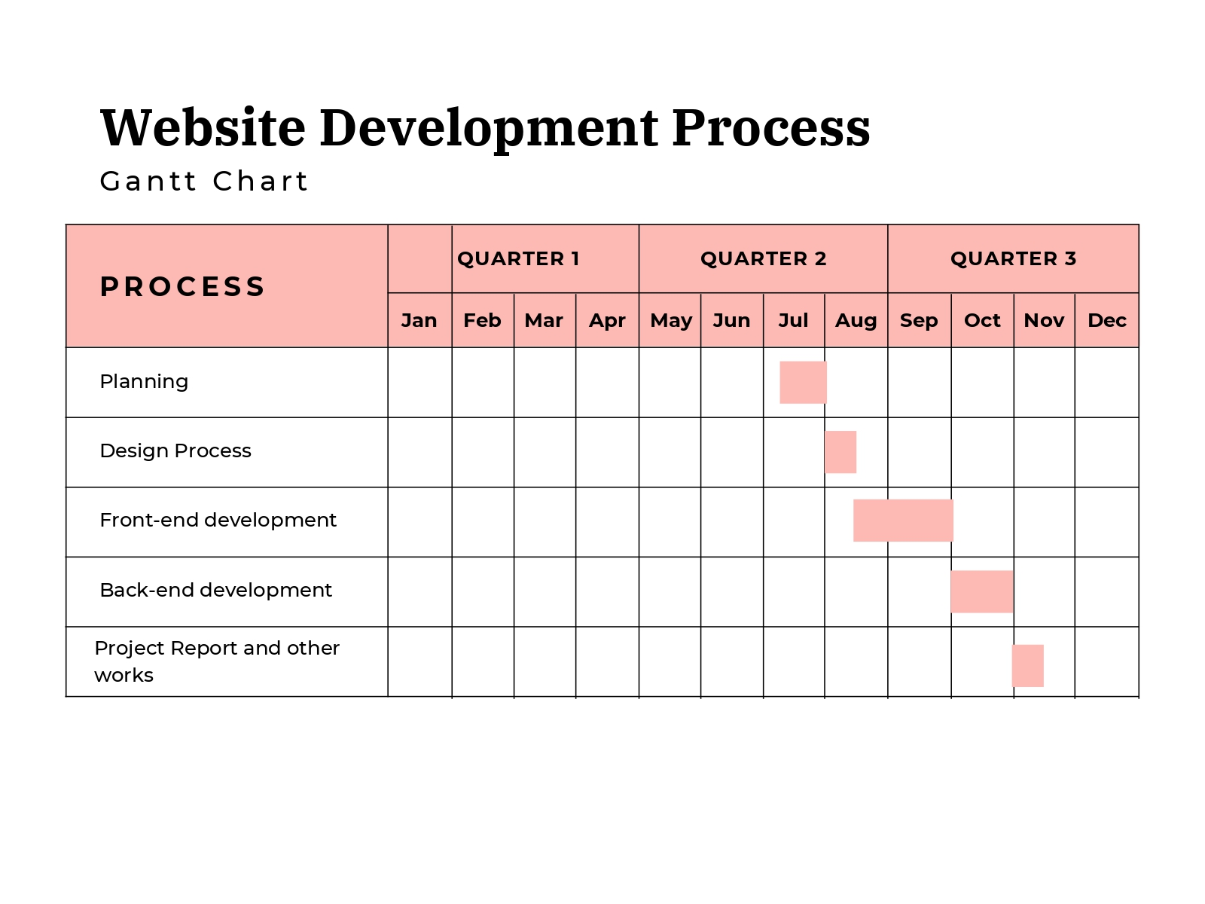

* + 1. SYSTEM ARCHITECTURE

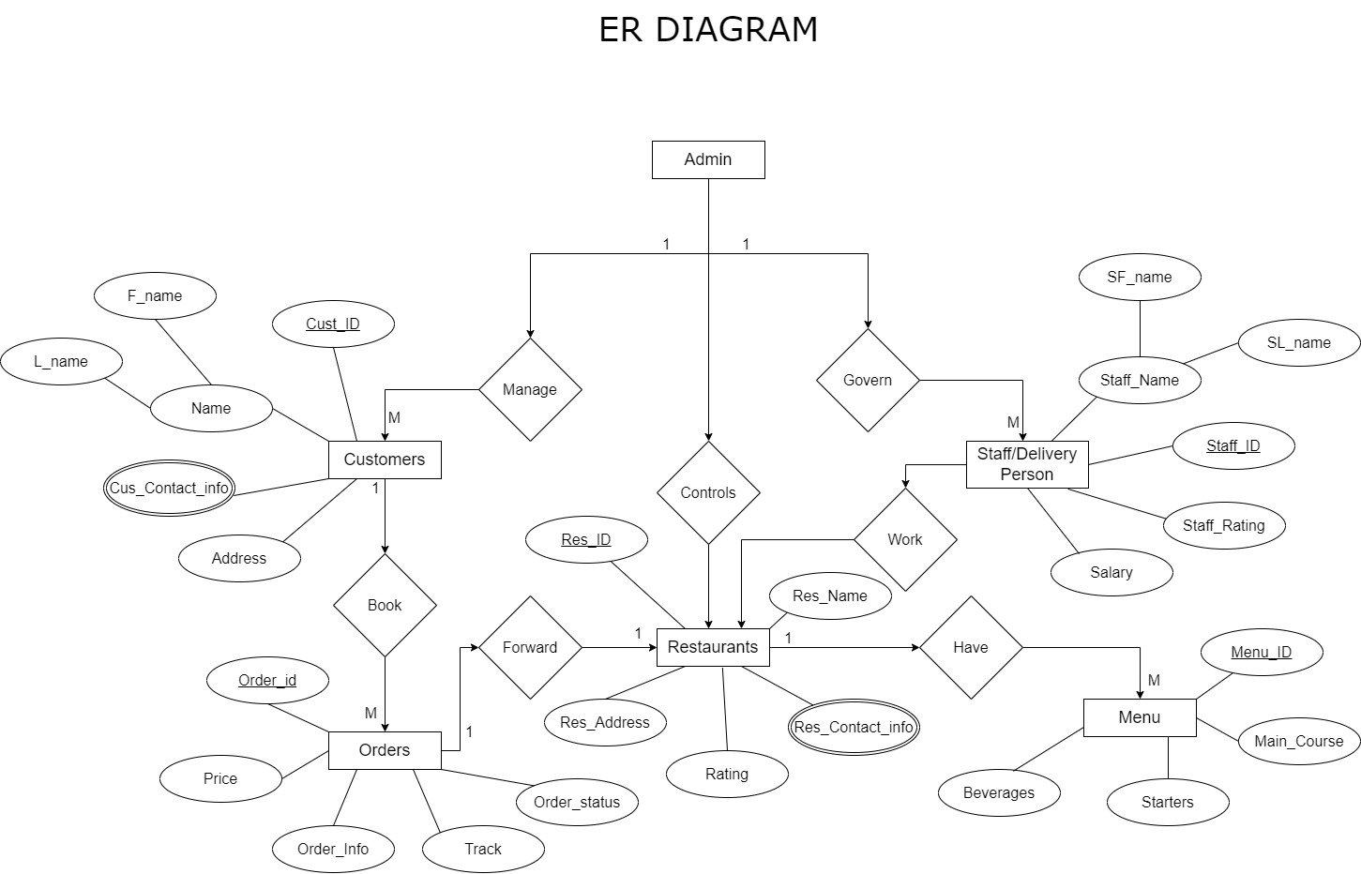

* + 1. FLOW CHART

Use case Diagram:

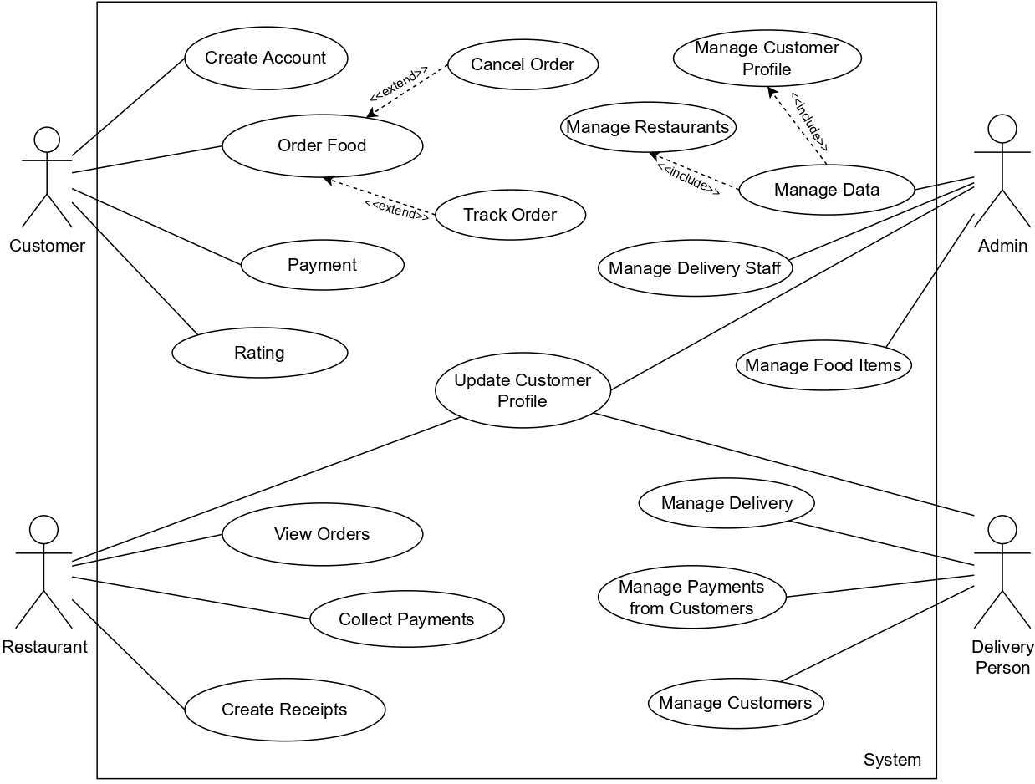

* 1. METHODOLGY /PROCEDURES
* **Requirement Phase:**

In this phase, the project title had been selected. The project title for the system was Food Ordering System (“EAT & GREET”). This project starting with brainstorming ideas with supervisor and proposed the title of the project. An abstract and description of the project module has also been done and attached. Besides, the Gantt chart also needed as a guideline and references for the project. This phase is to analyse the existing system and the article of the techniques or method that will be used for this project. In this phase also get all the requirements that are needed to design and develop the new system. Based on the collection of information through article, method and technique that is suitable been decided.

* **Design Phase:**

In the design phase, all the data or requirement obtained during planning and analysis phase transformed into the design. Diagrams to show the flow of the system will be develop in this chapter such as Context Diagram (CD), Use Case Diagram (UCD) Level 0 and 1, Entity Relationship Diagram (ERD). These diagrams are designed as a guideline to developing the system. After that, will be design the database and system interface.

* **Development Phase:**

This phase is where the design will implement into the coding. The system will develop regarding the user and system requirement. In this project, to develop the system will be use Xampp server for the database, Visual Studio Code to code and Bootstrap as framework. This phase is a critical phase because user part needed to fulfil and to make sure the objectives accomplish.

* **Testing Phase:**

When all the module has be done as full system, the system testing has been carried out. This testing phase will test the system to check the error and ensure the function run well as a whole system. Any error or bugs will be fixed and repeated testing the system until all the function can be use.

* **Review Phase**

This phase got feedback and review form user for the maintenance. In this phase will follow-up with user to upgrade the system to another version in the future.

## RESULT AND DISCUSSIONS

Home page

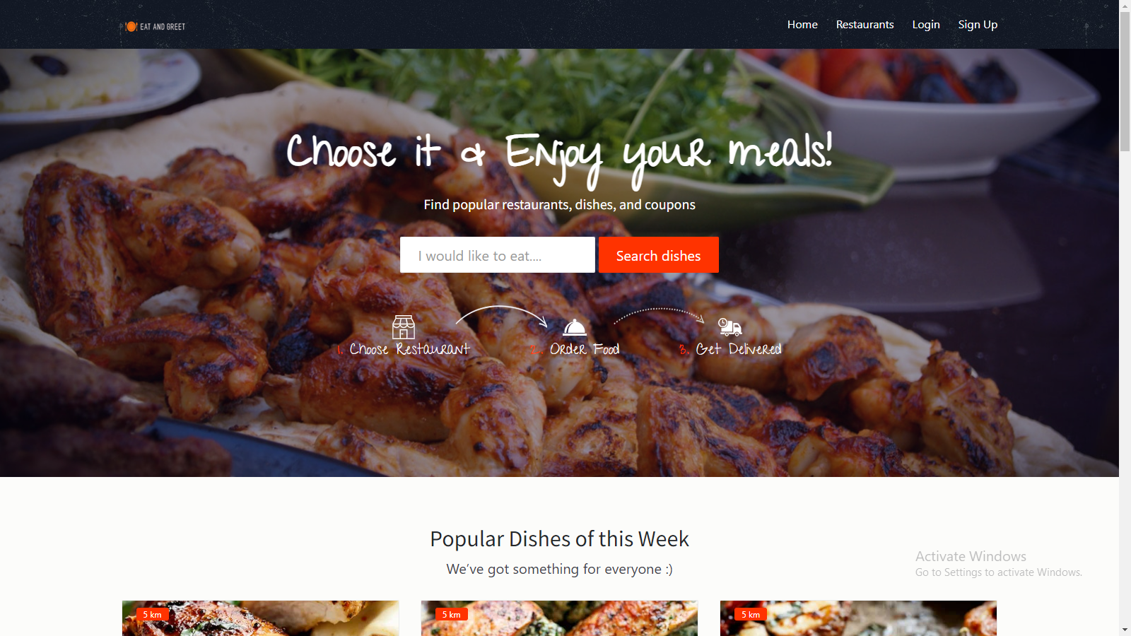

Sign Up Page

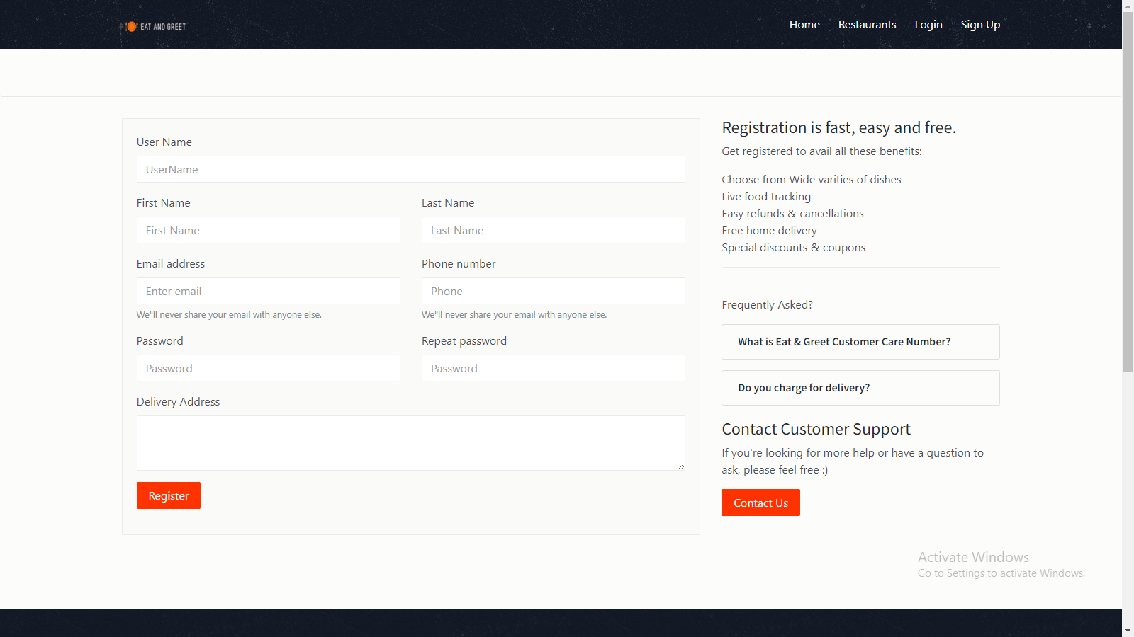

Restaurants Page

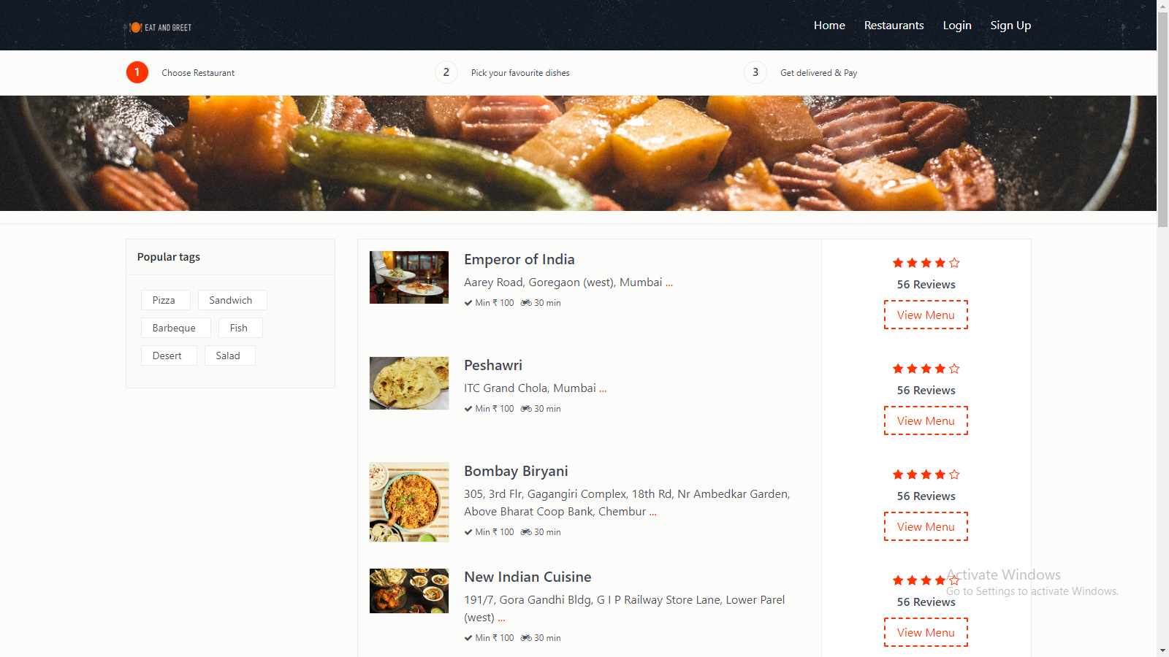

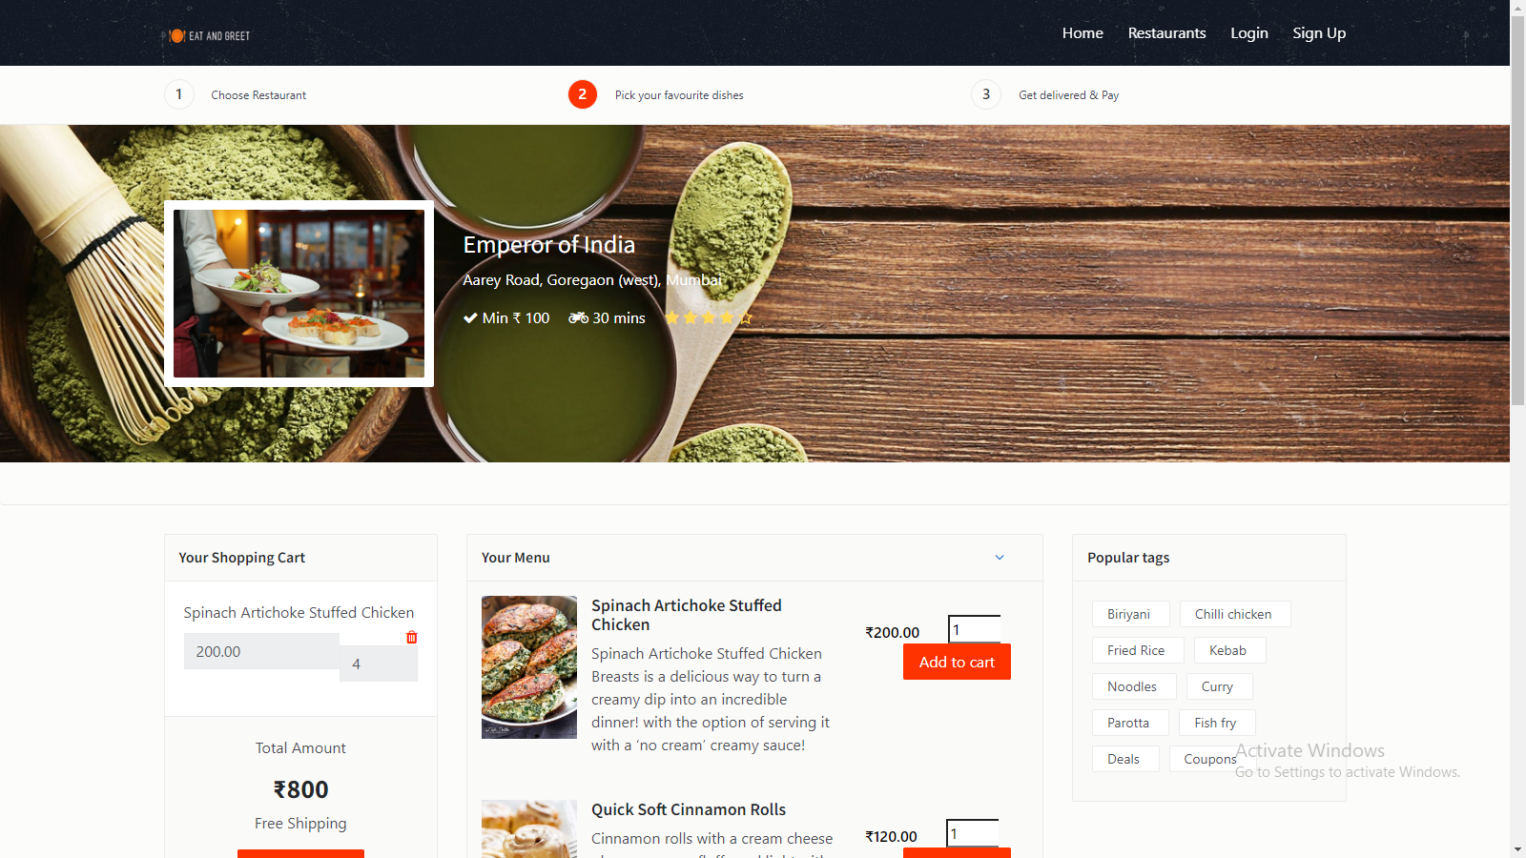

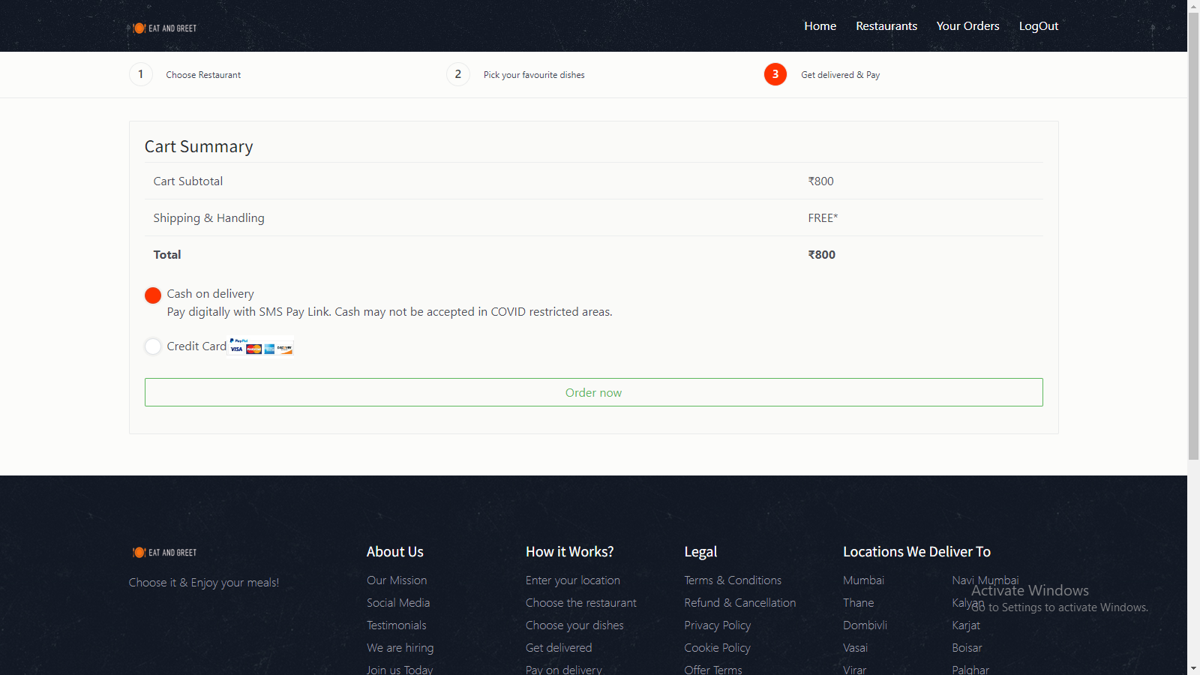 Checkout Page

Order Page

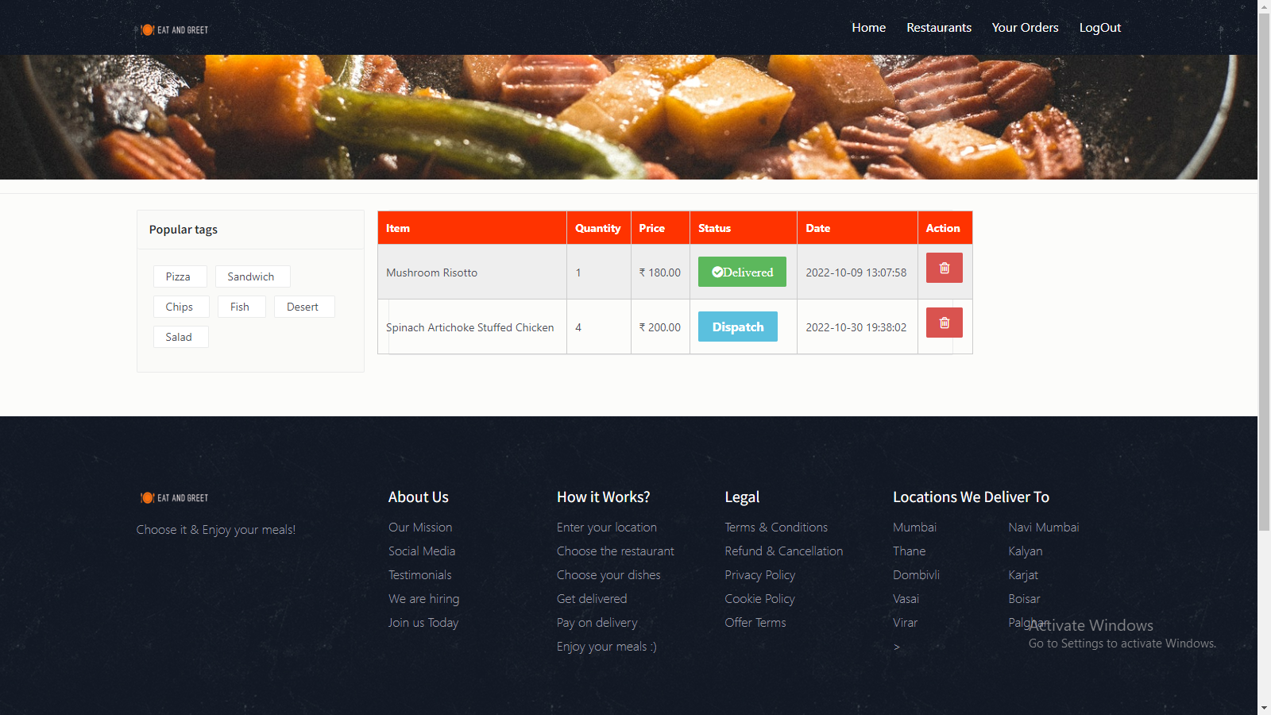

Admin Page

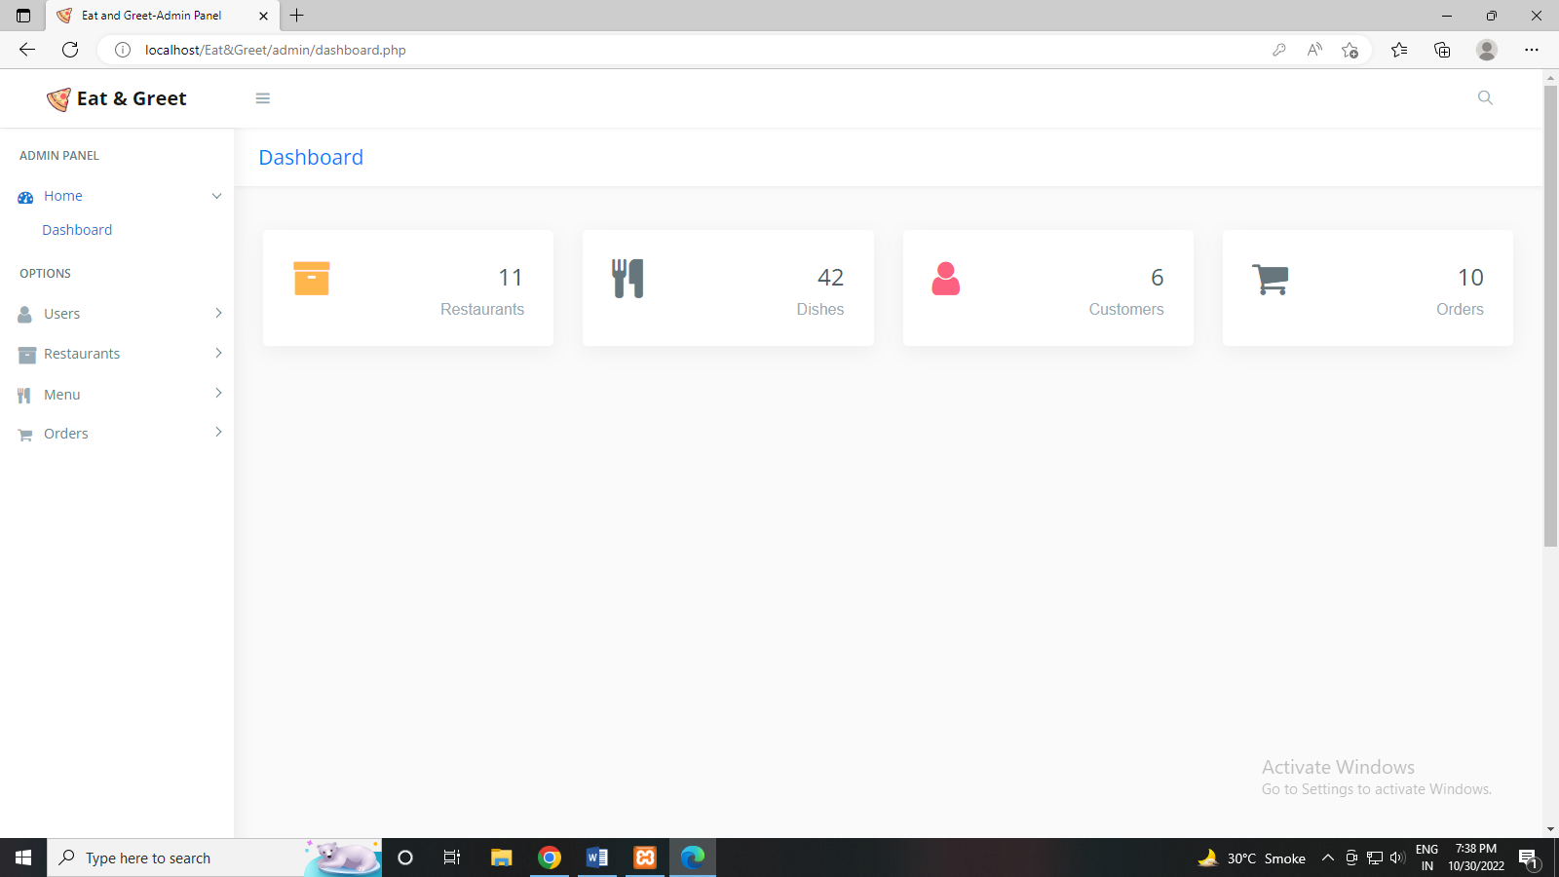

Admin Order Page

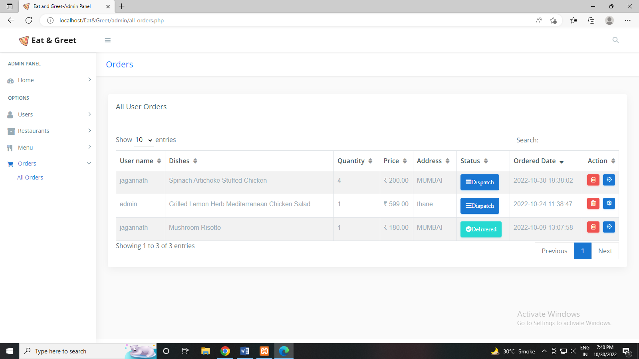

**5.CONCLUSION**

The software development is never completed. There is always a need for modification. There could have been other approaches to implement the system. I have tried to my level best to make the system an interactive as possible. The system has been developed with much care and free of errors and at the same time it is efficient and less time consuming.

The purpose of this project was to develop a web application for purchasing items from a shop. This project helped us in gaining valuable information and practical knowledge on several

topics like designing web pages using html & css, usage of responsive templates, designing

of android applications, and management of database using mysql. The entire system is

secured. Also the project helped us understanding about the development phases of a project

and software development life cycle. We learned how to test different features of a project.

This project has given us great satisfaction in having designed an application which can be

implemented to any nearby shops or branded shops selling various kinds of products by

simple modifications.

**About this Project**

1. It is simple and user friendly

2. Platform independent

3. Wide scope for future expansion

4. Manual as well as paper works can be fully eliminated in the billing branch

5. Accuracy and reliability are surely increased

6. It make sure that unauthorized personal cannot execute this program

System security refers to the technical innovations and procedures applied to hardware and

operating system. To protect against deliberate or accidental damage from a defined threat. In

contrast, data security is the protection of data, some loss, disclosure, modification and

destruction.

The system security problem can be provided into four related issues.

1. Security

2. integrity

3. privacy

4. access procedures

To implement this application server side technology used to create the web pages is PHP. PHP has several advantages such as enhanced performance, scalability, built-in security and simplicity. The database used to store the data is MySQL database. In the course of the implementation of this application many lessons have been learned including designing an interface, database access technique and programming for the web. This application helped in understanding the different technologies used to create interactive web pages. The implementation of the project has given a precise knowledge of how PHP is used to create web pages and how to connect to MySQL database. Overall the implementation of this project was an excellent learning opportunity.

## REFERENCES

* John O'Donovan and John Dunnionv (2014), “A Framework for Evaluation of Information Filtering Techniques in an Adaptive Recommender System”, Conference Paper in Lecture Notes in Computer Science, August 2004, doi: 10.1007/978-3-540-24630- 5_62
* Website http://abhidemo.com/demo/food/index.php, Abhi Restaurant by AbhiAndroid,
* 2017
* Website https://www.phpzag.com/star-rating-system-with-ajax-php-and-mysql/, Star
* Rating System with Ajax, PHP and MySQL by PhpZag Team, 28 January 2019
* Website: https://www.infoworld.com/article/3237508/what-is-agile-methodologymodern-software-development-explained.html, What is agile methodology? Modern
* software development explained, Isaac Sacolick, 25 Feb 2020
* Website: https://www.slideshare.net/armanreza161/food-ordering-system/, Food
* Ordering System, Arman Ahmed, Mymensingh weber solution, 21 April 2017